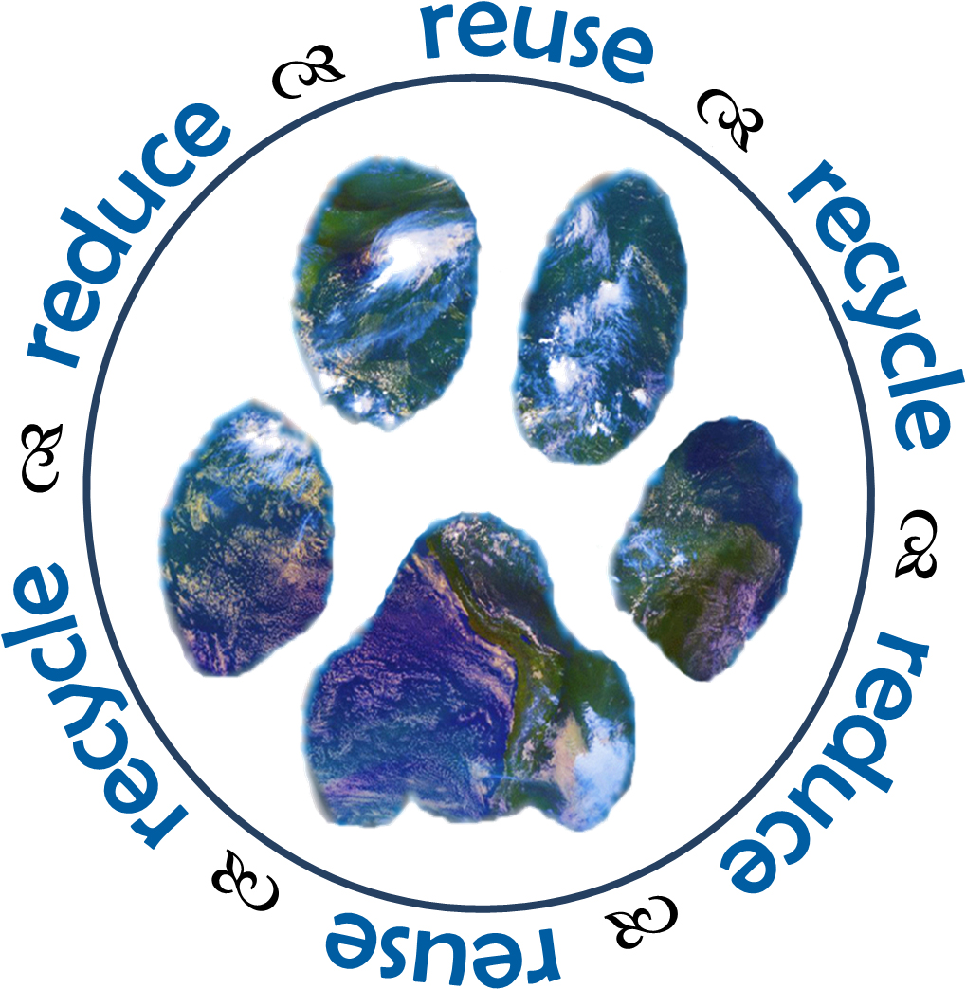

April 22nd – April 25th

**Please join us in celebrating Earth Day all week long!**

**Tuesday:** Walk to School and Wear Green!

If possible, try to walk to school or ride your bike instead of driving. Don’t forget to dress in your best green get-up! Students will be participating in activities to celebrate Earth Day within their classrooms.

**Wednesday:** Waste Free Wednesday

Please try to pack a lunch that is waste free. You could use Tupperware containers instead of plastic bags.

**Friday:** Trash Pick - Up

Remember to wear your sneakers! During recess we will be picking up litter off the school grounds in partnership with Living Green Howard County.